Data Driven Business Report: Global Superstore (2013 - 2015)
Introduction:
This report highlights an analysis of a global retail company’s performance using data from Global Superstore. The purpose of this report is to offer insights into sales, profit, regional performance, salesperson performance, and product returns from 2013 to 2015. Tableau software was applied to develop visualizations to aid management decision-making.
Methods:
The data was analyzed using Tableau Public. Two data sets used for analysis include Global Superstore Orders and Global Superstore Returns. Data for 2013 to 2015 was used for analysis. Charts used for analysis include bar charts, maps, and line graphs. Distinct counts were used for order analysis. A calculation was used to determine orders that are returned. A dual-axis chart was used to compare sales orders to product returns.
Findings & Visualization:
Profit Trends Over Time (Category and Segment):
Analyzing the profit trend across the years, Technology increased steadily from 2013 to 2015 for all consumer groups. Of all the groups, Consumers had the most significant increase, while the Furniture profit trend was volatile. This trend suggests that the future profitability will solely depend on sales through technology and the Consumer group.

1. Sales by Product Type:
The sales from Technology were highest over the three-year period. The next highest sales were from Furniture and Office Supplies.
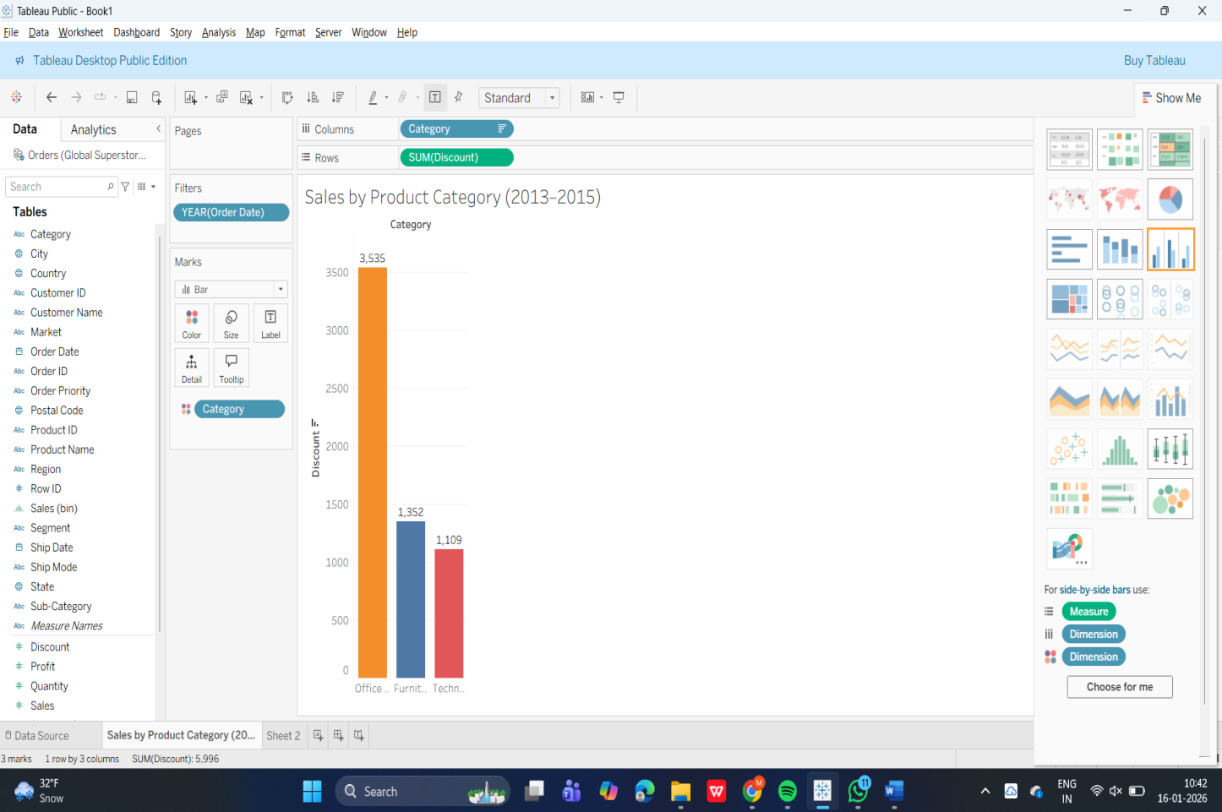

Figure 1. Sales by Product Category (2013–2015).
For the last three years, the total sales by category reveal the following: Technology is the leader, Office Supplies is the closest follower, and Furniture is the last in the list. This indicates that the key sales driver is Technology, and the key to improved sales performance lies in the same area.

2. Profit by Product Category
Technology was the most profitable category, while the Furniture category had low profit margins even though their sales were good.

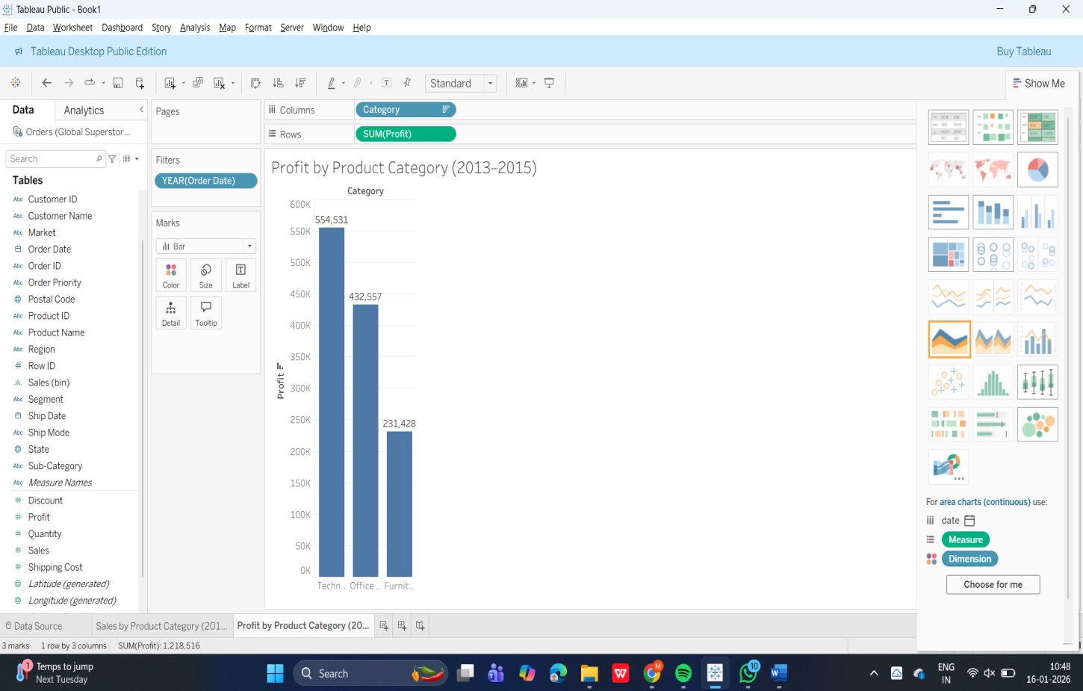

Figure 2. Profit by Product Category (2013–2015).
On the profitability side, Technology leads the way in terms of strongest profitability, Office Supplies making moderate progress, and Furniture trailing the others. The moral of the story here is that there may be some pricing, cost, or efficiency gaps in the Furniture sector that need to be closed, in addition to maintaining the strong Tech profitability.

3. Profit by Country:
Regions like the United States and Europe were the most profitable ones. Certain regions had low or even negative profits, pointing towards the requirement for strategic evaluation.
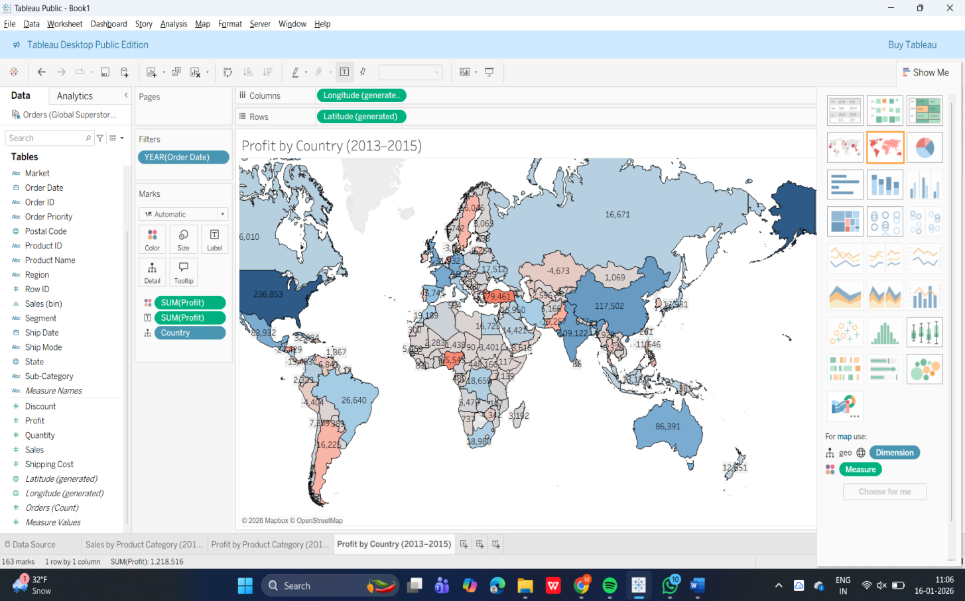

Figure 3. Profit by Country (2013–2015).
The geographic perspective indicates that the United States is the most lucrative market for the company. There are other countries that record slight positive profits. There are some countries that are close to the break-even point or negative profit margins. This indicates that the market or the operation of the company is faced with challenges. There are regions where the company records its profits. This indicates that specific strategies can be employed to improve the situation in regions where the company records negative results.

4. Nations with Fewest Sales:
Some countries registered only a few sales, perhaps because their presence in the market is limited or demand is low.
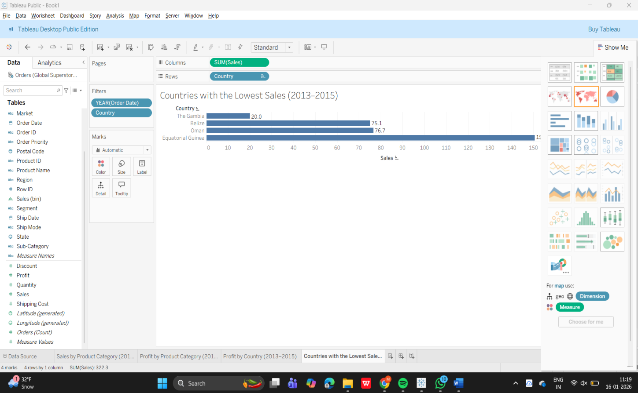

Figure 4. Countries with the Lowest Sales (2013–2015).
The above bar graph illustrates the markets with the lowest combined sales. Such markets are generating little revenue and therefore show low market penetration. The message here is to consider investing in such markets or shifting resources to other performing markets.

5. Top Salespeople by Sales and Profit:
By Sales:
The top performers were identified through sales and profit. Variations between high sales and high profit performers indicate the need for balanced incentive programs.
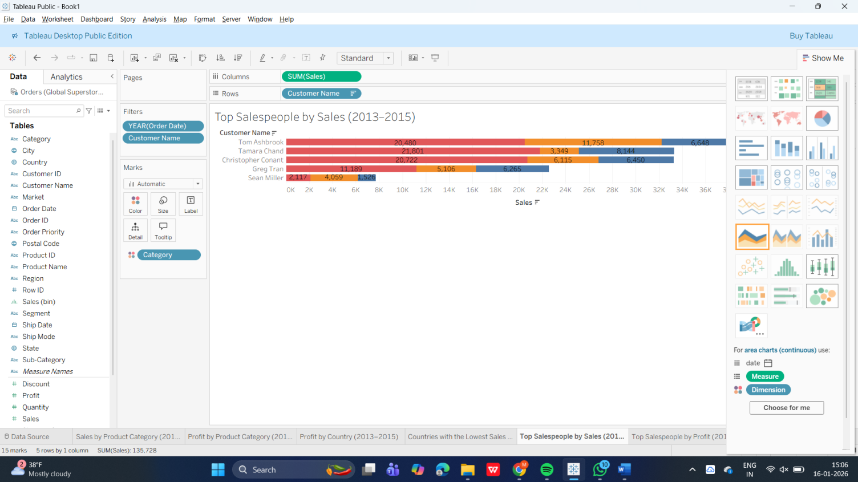

Figure 5. Top Salespeople by Sales (2013–2015).
This graph draws attention to the highest earners based on total sales for the period of three years. A small group of salespeople is responsible for the majority of the sales, and based on the colors used, Technology and Office Supplies are the primary contributors to their success.

By Profit:
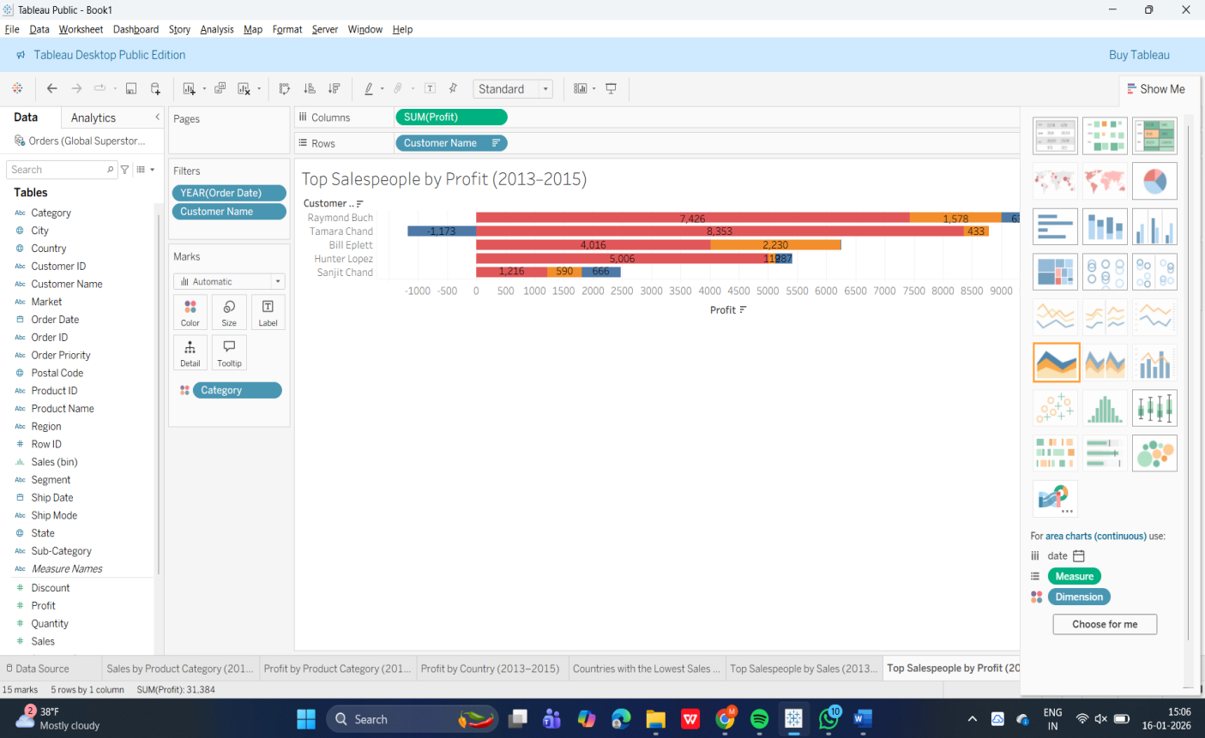

Figure 6. Top Salespeople by Profit (2013–2015).
Sellers with the greatest profits are identified by this perspective. A degree of overlap is present between sellers with high profits and the best sales performance, but not necessarily between the best sales performance and the greatest profits. A greater contribution is made by individuals with a focus on high-margin product groups, thus supporting profit as a basis for motivation.

6. Sales Orders vs. Product Returns:
The sales orders grew from 2013 to 2015, while the returns showed a slight growth but remained much lower, suggesting improved quality.
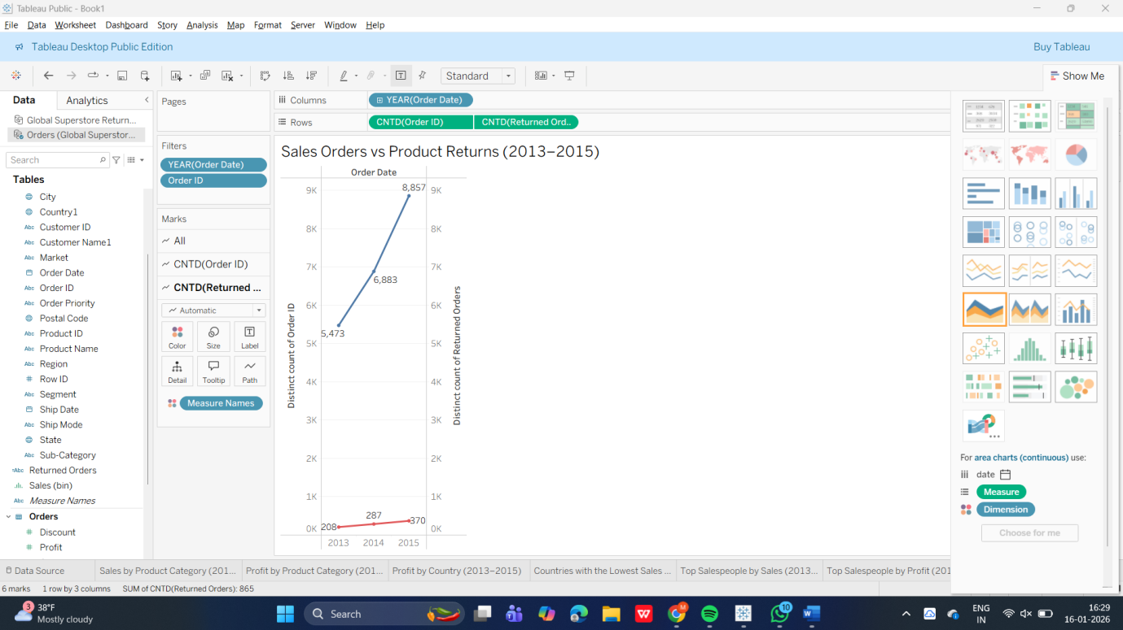
Figure 7. Sales Orders vs Product Returns (2013–2015).
This graph allows for the comparison of the number of sales orders to the number of product returns for the period between 2013 and 2015. It is clear that the number of sales orders has steadily risen over the three-year period, and this is evidence that the business is growing. Although the number of product returns has also risen, this number is still significantly lower than the number of sales orders.
Sales and Profit forecast for 2016:
Notwithstanding the favorable trends in sales and profit during the period from 2013 to 2015, there are expectations of further growth in sales and profits in 2016. Technology is expected to be the major contributor to revenue and profit, with favorable results in the growing regions of North America and Europe. Based on the trends, modest profit growth and return ratios can be expected.
Conclusion and Recommendations:
The company has shown a steady growth in the area of sales and profits from 2013 to 2015. The areas where the company is performing well should be invested in. Cost optimization is recommended where the profit is low. Sales incentives should be given based on both revenue and profit. Return trends should be monitored to ensure customer satisfaction.
Together, these visualizations form a cohesive data-driven story that highlights growth drivers, profitability patterns, geographic strengths, operational risks, and strategic opportunities for the company.

References
Tableau Software. (2016). Global Superstore dataset. https://www.tableau.com
Few, S. (2012). Show Me the Numbers: Designing Tables and Graphs to Enlighten. Analytics Press.

